Technical Report
GLOBAL 2000 LIST BY THE CENTER FOR WORLD UNIVERSITY RANKINGS
Author: Jonathan Kateega
Access No.: B34976

Raw Data
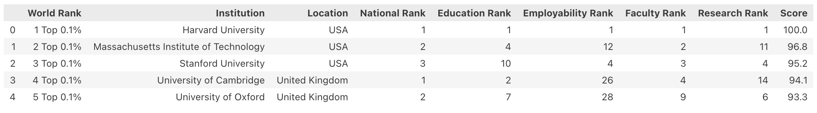
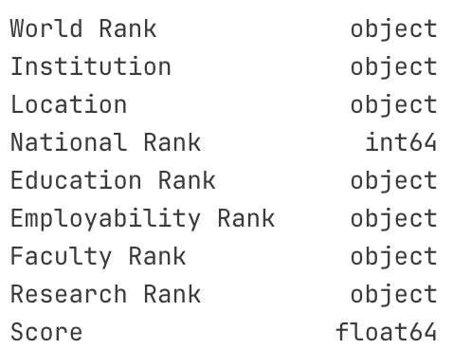

The raw dataset extracted from the CWUR website (World University Rankings 2025, https://cwur.org) contains 2000 samples and 9 features. For each sample (institution), there are eight observations including the (1) location, (2) national rank, (3) education rank, (4) employability rank, (5) faculty rank, (6) research rank, (7) score, and the (8) world rank.

Of the 9 features, only the National Rank and Score are numerical type (integer and float, respectively). All other columns, while containing values that appear numerical in nature, bear categorical data types (object). In this form, analysis and comparison is impeded, and adjustment to numerical data is required in order that information and insights can be extracted. Datatype conversion comes later in the report.

Duplicates
There are no duplicates in the raw data.

Missing Values
An initial check for missing values shows there are 29 missing values (1.45%) in the Faculty Rank column. At this point it is safe to discard the rows where data is missing, as they form only 1.45% of the dataset.

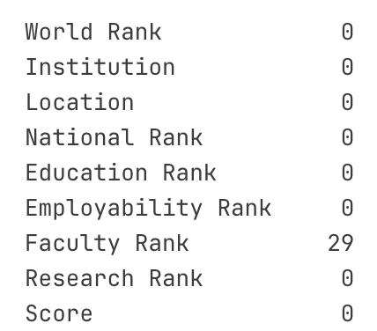

Datatype Conversion
I thought it was peculiar for features that appear numerical are object type. When it came to datatype conversion, I discovered right before converting these columns to numerical that there are “-“ values in them.

Number of “-“ values in each column:
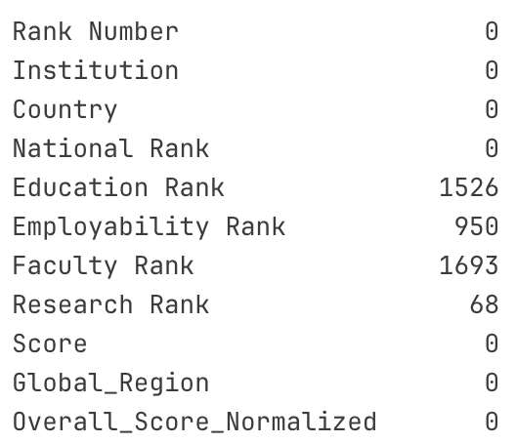

“-“ values expressed as a percentage

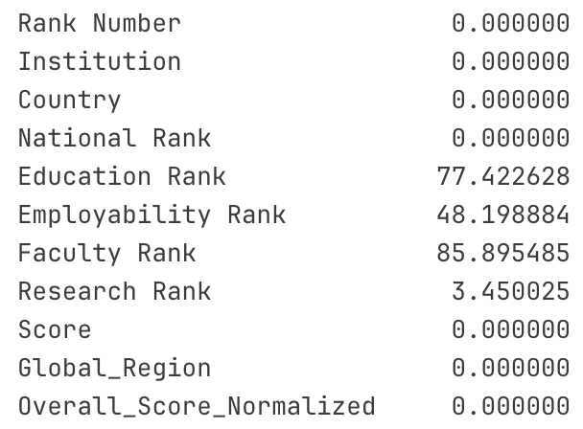

With this insight, in the previous steps, deleting the 29 rows where Faculty Rank is NaN rows not the correct thing to do. There are far more rows where the Faculty Rank is "-". Given the nature of this dataset (university ranking), I am interpreting both these values as:
- Ranking not assigned, or
- Score unavailable or institution not evaluated.

Clean Data
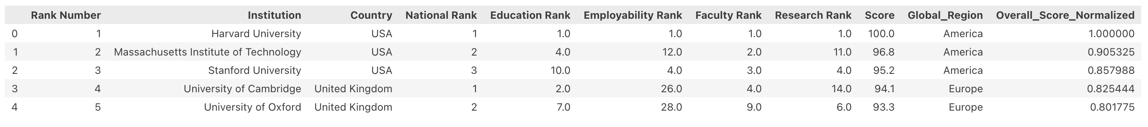
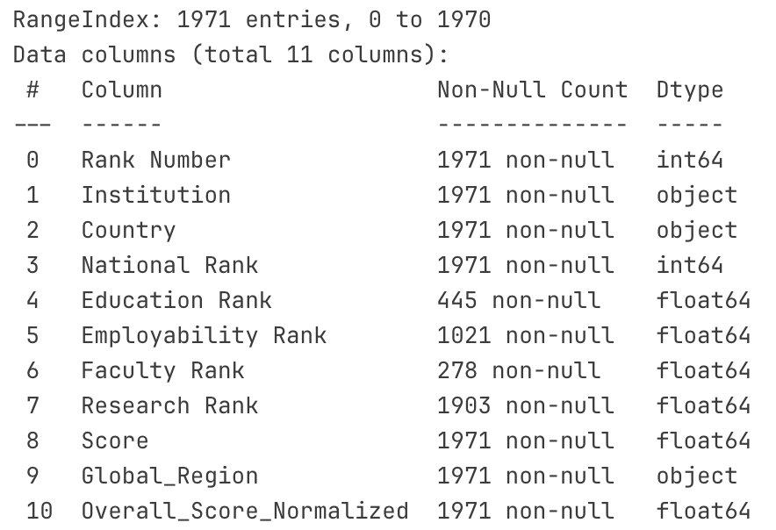

The cleaned dataset contails 1971 samples (decreased after removing rows where the "Fcaulty Rank" is missing), and 11 features (increased from 9 in the raw data). The population in the dataset is the (institution + Country + Global_Region), which is always unique. The population is compared across the observations (1) Rank Number, (2) National Rank, (3) Education Rank, (4) Employability Rank, (5) Faculty Rank, (6) Research Rank, (7) Score, and (8) Overall_Score_Normalized.

Hypothesis Testing
- Null Hypothesis (H₀) - missingness is statistically related to the Region
- Alternative Hypothesis (H_{a}) - there is no statistically strong relationship between missing data and Region

I choose to use the Chi-Square Test, introducing first a binary column (1, 0) to indicate missing or not missing, and test independence of categories.

If p < 0.05, missingness depends on region (not random).
If p ≥ 0.05, no significant association found (possibly random).

For each of the columns Faculty Rank, Research Rank, Employability Rank, and Education Rank; the “missingness” is statistically related to the Region (hence not random). With this in mind, a group-wise median imputation would be suitable for imputing missing data in a later step for feature preparation for modelling. This would be suitable for the column “Research Rank” and “Employability Rank”.

For “Faculty Rank” and “Education Rank”, where the data is missing >75% of the time, the feature distribution is likely unreliable, and any imputation might introduce bias unless the missingness is totally random (I have found that it is not random).

If it is the case for example that “small” universities in certain regions tend not to report certain metrics, then imputing might artificially inflate or distort the rankings.

